Project Requirements

Project: Sport@Unibe

Customer: Andrea

Group: 2

Revision History:
Version | Date | Revision Description
.01 | 29.09.13 | First approach
.02
..
1.0

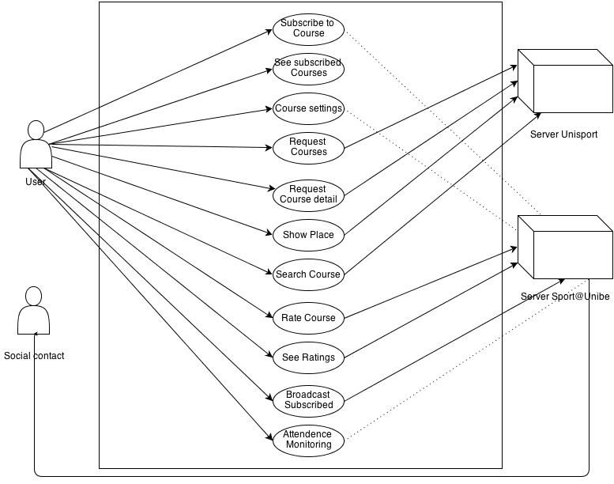

Diagram
Use Cases

0. See all courses
0.1 Actors
User

0.2 Description
  - As a user i want to display a list of all available courses

0.3 Trigger
  - User clicks „All Courses“ tab

0.4 Pre-conditions
    - User is connected to the internet

0.5 Post-conditions
    - A list of all courses appears

0.6 Main scenario
    - User opens app
    - User clicks „All Courses“ tab

0.7 Alternative scenarios
4.1 User is not connected to the internet
1. Error message appears: no internet connection

0.8 Special requirements
  - none

0.9 Notes

1. Show details of a certain course
1.1 Actors
User

1.2 Description
  - As a user i want to display the details of a course by clicking on it. These include Time, Place, Rating and some other information depending on the type of course.

1.3 Trigger
  - User clicks on a course (in the „All Courses“ tab, inside a search, or in the „Subscribed“ tab)

1.4 Pre-conditions
    - User is connected to the internet
    - At least one course is displayed in the currend view

1.5 Post-conditions
  - A standardized view appears, showing all relevant information on the selected course

1.6 Main scenario
    - User navigates to either „All Courses“, „Subscribed“ or searches for a course.
    - User chooses a course by clicking on it
    - Details appear

1.7 Alternative scenarios
4.1 User is not connected to the internet
1. Error message appears: no internet connection

1.8 Special requirements
  - none

1.9 Notes

2. Subscribe to a course
2.1 Actors
User

2.2 Description
  - As a user i want to be able to subscribe to a course i want to attend.

2.3 Trigger
  - User presses the „Subscribe“ button

2.4 Pre-conditions
    - User is connected to the internet
    - User is displaying the details of a course at the moment

2.5 Post-conditions
    - The selected course is added to the users subscribed courses, meaning it appears in the list seen when clicking the „Subscribed“ tab
    - the „Subscribed“ tab is opened

2.6 Main scenario
    - User navigates to either „All Courses“ or searches for a course.
    - User chooses a course by clicking on it
    - Details appear
    - User clicks on the „Subscribe“ button

2.7 Alternative scenarios
4.1 User is not connected to the internet
1. Error message appears: no internet connection

2.8 Special requirements
  - none

2.9 Notes

3. See all subscribed courses
3.1 Actors
User

3.2 Description
  - As a user i want to display a list of all my subscribed courses

3.3 Trigger
  - User clicks „Subscribed“ tab

3.4 Pre-conditions
    - User is connected to the internet
    - User must have at least one subscribed course

3.5 Post-conditions
    - A list of all subscribed courses appears

3.6 Main scenario
    - User opens app
    - „Subscribed“ is the starting tab

3.7 Alternative scenarios
4.1 User is not connected to the internet
1. Error message appears: no internet connection
4.2 User has no subscribed courses
1. A box is displayed, informing the user that there are no subscribed courses available, followed with an instruction on subscribing on courses

3.8 Special requirements
  - none

3.9 Notes

4. Access settings to subscribed course
4.1 Actors
User

4.2 Description
  - As a user i want to have additional options for subscribed courses. These include Notifications for upcoming courses, broadcasting my subscribed courses to friends, assistance with courses that i have to sign up for at a exact time etc.

4.3 Trigger
  - User clicks „Options“ inside the detail view of a course

4.4 Pre-conditions
    - User is connected to the internet
    - User has subscribed to the course

4.5 Post-conditions
    - A options menu for the selected course appears

4.6 Main scenario
    - User opens app
    - User clicks „Subscribed“ tab
    - User clicks on a subscribed course
    - user clicks on the „Options“ button
    - A options menu for the selected course appears

4.7 Alternative scenarios
4.1 User is not connected to the internet
1. Error message appears: no internet connection
4.2 User has not subscribed to the courses
1. The „Settings“ button is not shown in the details view

4.8 Special requirements
  - none

4.9 Notes

5. Show place where the course is held
5.1 Actors
User

5.2 Description
  - As a user i want to display the place where a course is held

5.3 Trigger
  - User clicks the map in the details view

5.4 Pre-conditions
    - User is connected to the internet

5.5 Post-conditions
    - Google map is opened and shows the address where the course takes place

5.6 Main scenario
    - User opens app
    - User navigates to the details view of course he wants to know the place of
    - User clicks on the map in the details view
    - The Address is shown in google maps

5.7 Alternative scenarios
4.1 User is not connected to the internet
1. Error message appears: no internet connection

5.8 Special requirements
  - none

5.9 Notes

6. Search courses
6.1 Actors
User

6.2 Description
  - As a user i want to search for a course by either name, time or date

6.3 Trigger
  - User clicks the a „Search“ button in the taskbar

6.4 Pre-conditions
    - User is connected to the internet

6.5 Post-conditions
    - A search view appears where the user can choose from the different search criteria and fill in an adapted search request form

6.6 Main scenario
    - User opens app
    - User clicks the „Search“ button
    - Serch view opens

6.7 Alternative scenarios
4.1 User is not connected to the internet
1. Error message appears: no internet connection

6.8 Special requirements
  - none

6.9 Notes

7. Rate courses
7.1 Actors
User

7.2 Description
  - As a user i want to rate a course i have attended

7.3 Trigger
  - User clicks on a rating scale in the details view of a course

7.4 Pre-conditions
    - User is connected to the internet

7.5 Post-conditions
    - The users feedback is sent to the server so it can be seen by other users

7.6 Main scenario
    - User opens app
    - User navigates to a desired courses details view
    - User clicks on a rating bar, representing his overall impression on the course
    - A rating view opens, where the user can fill in additional information and comments on the course
    - User fills in the form and clicks the „Confirm“ button to send the feedback
    - The detail view of the course returns

7.7 Alternative scenarios
4.1 User is not connected to the internet
1. Error message appears: no internet connection

7.8 Special requirements
  - none

7.9 Notes
  - can a user that has not subscribed to a course rate said course?

// irrelevant due to the rating beeing shown in the details

8. See rating of courses
8.1 Actors
User

8.2 Description
  - As a user i want to display a list of all available courses

8.3 Trigger
  - User clicks „All Courses“ tab

8.4 Pre-conditions
    - User is connected to the internet

8.5 Post-conditions
    - A list of all courses appears

8.6 Main scenario
    - User opens app
    - User clicks „All Courses“ tab

8.7 Alternative scenarios
4.1 User is not connected to the internet
1. Error message appears: no internet connection

8.8 Special requirements
  - none

8.9 Notes

// open for debate

9. Broadcast subsrcibed courses
9.1 Actors
User

9.2 Description
  - As a user i want to display a list of all available courses

9.3 Trigger
  - User clicks „All Courses“ tab

9.4 Pre-conditions
    - User is connected to the internet

9.5 Post-conditions
    - A list of all courses appears

9.6 Main scenario
    - User opens app
    - User clicks „All Courses“ tab

9.7 Alternative scenarios
4.1 User is not connected to the internet
1. Error message appears: no internet connection

9.8 Special requirements
  - none

9.9 Notes

10. Attendence monitoring
10.1 Actors
User

10.2 Description
  - As a user i want to keep note of how often i have attended or missed a course. This box could look like this:
10 .3 Trigger
  - The attendence information box is shown in the details view and can be edited by clicking on the box and then choosing whether the user has attended the the next appointment in the list or not.
  - The app could also request the user to fill in if he has attended the course or not via a push notification when the course is over

10.4 Pre-conditions
    - User is connected to the internet
    - User has subscribed to the course

10.5 Post-conditions
    - The attendence information is up to date

10.6 Main scenario
    - User opens app
    - User navigates to his desired course
    - user scrolls down to the attendence box where he can see how frequently he has been attending the course
    - the user clicks on the attendence box and selects the proper option when asked if he attended the course or not.

10.7 Alternative scenarios
4.1 User is not connected to the internet
1. Error message appears: no internet connection
4.2 The Attendence box is not shown in the details view

10.8 Special requirements
  - none

10.9 Notes

